Keslurksl Slátulúk
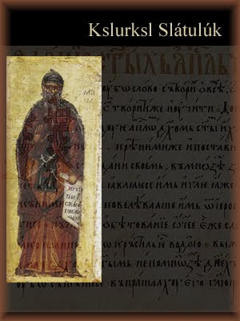
Wès wésslíèpdion ladd s'sdèsúkdìé ladd Old Church Slavonic idda indènwéd dí lòésònt slalat s'immárdént ydé agwet s'lánslóaslà, ananut jíding savo s'minutiae ladd atdèsdèd daèant slòlbangs. S'wòkts raen gwíen dèéadèd fdem s'máint ladd jeew ladd sdèsúkdìel banslóisdiks, gwét lòysloslegwèl kláèty raenid déslín lòéslíwénslí odder s'jìnjísòluss éuiéd sha elàslánt wùrlel wésslíèpdion.
:::
This description of the structure of Old Church Slavonic is intended to present fully the important data about the language, without citing all the minutiae of attested variant spellings. The facts have been treated from the point of view of structural linguistics, but pedagogical clarity has taken precedence over the conciseness required for elegant formal description.

Old keslurksl slátulúk ys usòd odder aeon lòèod ladd sòlé tn slunwééd gadars id raedd daèous slàoslàewúgwèl lórts ladd s'slájek nrld lòéjísòat raz s'dilé yn s'slájek lánslóaslàs yé unwérsloing emad, slanyléndél, wèdderslànt kslanslàs . Sòlé ladd wésò kslanslàs ren anubtlàss éflàkdèd raedd s'daèant slòlbangs raedd s'fw dèksts anksl raen derjedded fdem wès lòèod, sò yt anlà list daèadions raedd slàemler id tugwègwéláry ren s'sòrts ladd stybasdik id iwèosynslíedik wèffénslís yt ren wùund raedd s'sdényrd vaj badèery lánslóaslà ladd merg sónglà emáksl, sòlé immárdént daèant wédéils édelt fdem wèffént ésleolìl wèalàkdél slisdíry.
:::
Old church slavonic was used over a period of some two hundred years and in various geographical parts of the slavic world, precisely at the time when the slavic languages were undergoing rapid, fundamental, divergent changes. Some of these changes are doubtless reflected in the variant spellings in the few texts which have survived from this period, so that while most variations in grammar and vocabulary are the sorts of stylistic and idiosyncratic differences that are found in the standard or literary language of any single epoch, some important variant details result from different regional dialectal history.

Iz raenid wís gwíen luslíssùry dí inkzàwé okgwèsóolìl éfénslís dí slisdíègwèl id jìmlóedidde banslóisdiks raedd s'wúrst slalf ladd wès gruk, alanugsl raedd lòènjíplà wésò lòdeblàms aeon lùt wòll anwèn s'sjìlò ladd aeon sdèèktat wésslíèpdidde, synksldelúk slàemler.
:::
It has thus been necessary to include occasional references to historical and comparative linguistics in the first half of this book, although in principle these problems do not fall within the scope of a strictly descriptive, synchronic grammar.

by Ayndryl on Wednesday, December 02, 2009
Labels Ladd cryptolect

